**Report “Lab 10-11”**

**Anton Tserakhau**

# ETL

## Task 01: Loading to DIM SCD 2

I have created table T_ACTIONS that stores all history about changing links:

ALTER TABLE u_dw_references.t_actions

DROP PRIMARY KEY CASCADE;

DROP TABLE u_dw_references.t_actions CASCADE CONSTRAINTS;

CREATE TABLE u_dw_references.t_actions

(

action_id NUMBER ( 25 )

, child_geo_id NUMBER ( 22 )

, parent_geo_id_old NUMBER ( 22 )

, parent_geo_id_new NUMBER ( 22 )

, action_dt DATE

)

TABLESPACE ts_references_data_01;

CREATE UNIQUE INDEX u_dw_references.t_actions_pk

ON u_dw_references.t_actions ( action_id )

TABLESPACE ts_references_data_01;

ALTER TABLE u_dw_references.t_actions ADD (

CONSTRAINT t_actions_pk

PRIMARY KEY

(action_id));

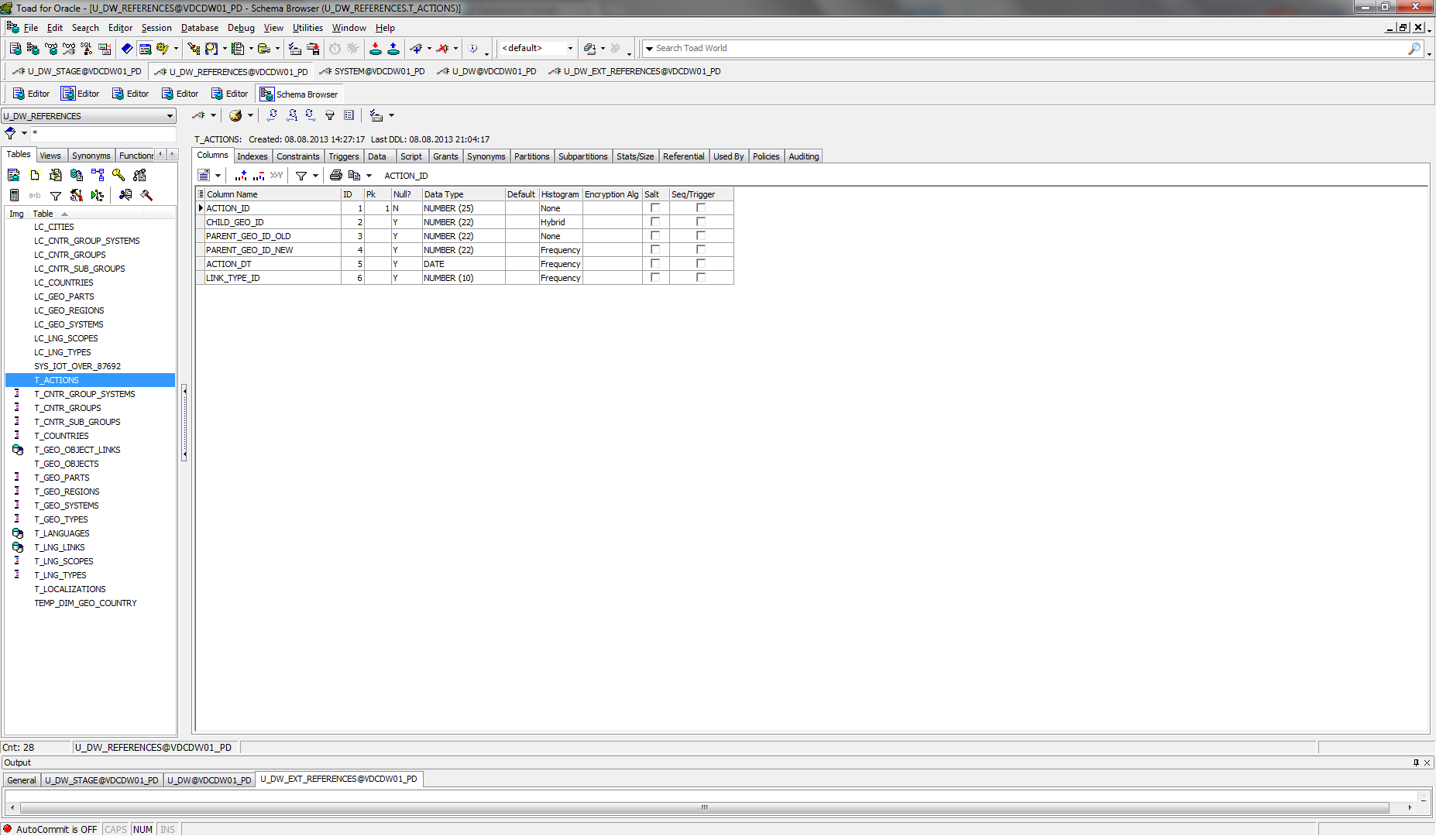

I have created script, which loads into table T_ACTIONS all changes (*pkg_etl_geo_actions_dw_ext_references*):

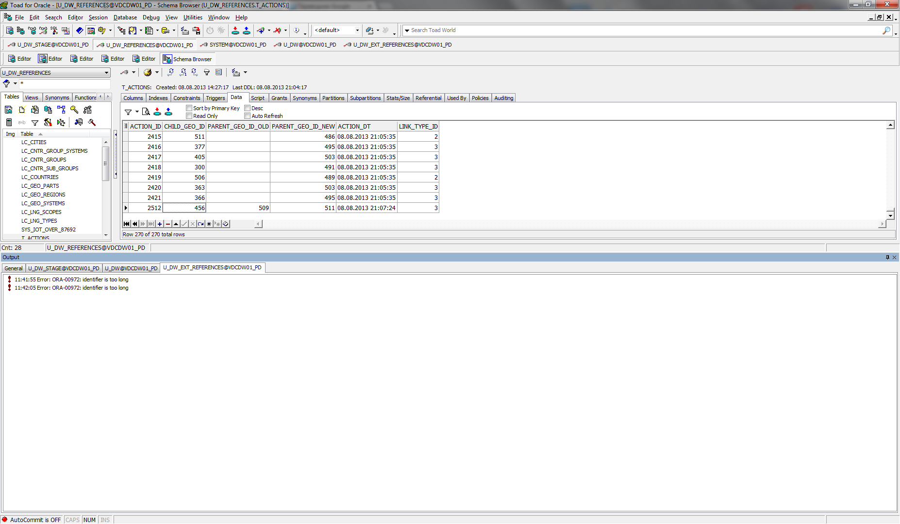

I have created dimension DIM_GEO_LOCATIONS_SCD

DROP TABLE U_DW.DIM_GEO_LOCATIONS_SCD CASCADE CONSTRAINTS;

CREATE TABLE U_DW.DIM_GEO_LOCATIONS_SCD

(

SURR_ID NUMBER(22),

COUNTRY_GEO_ID NUMBER(22),

COUNTRY_ID NUMBER(22),

COUNTRY_CODE_A2 VARCHAR2(30 CHAR),

COUNTRY_CODE_A3 VARCHAR2(30 CHAR),

COUNTRY_DESC VARCHAR2(200 CHAR),

REGION_GEO_ID NUMBER(22),

REGION_ID NUMBER(22),

REGION_CODE VARCHAR2(30 CHAR),

REGION_DESC VARCHAR2(200 CHAR),

PART_GEO_ID NUMBER(22),

PART_ID NUMBER(22),

PART_CODE VARCHAR2(30 CHAR),

PART_DESC VARCHAR2(200 CHAR),

GEO_SYSTEM_GEO_ID NUMBER(22),

GEO_SYSTEM_ID NUMBER(22),

GEO_SYSTEM_CODE VARCHAR2(30 CHAR),

GEO_SYSTEM_DESC VARCHAR2(200 CHAR),

FROM_DT DATE,

TO_DT DATE,

STATUS VARCHAR2(15 BYTE)

)

TABLESPACE TS_DW;

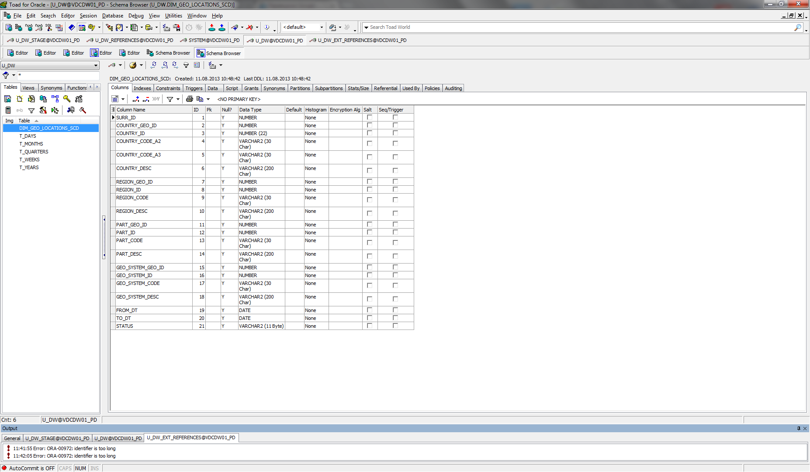

I have created script, which loads into table DIM_GEO_LOCATIONS_SCD data (*pkg_etl_dim_geo_locations_scd_dw*):

